**PaNOSC**

**Photon and Neutron Open Science Cloud**

**H2020-INFRAEOSC-04-2018**

**Grant Agreement Number: 823852**

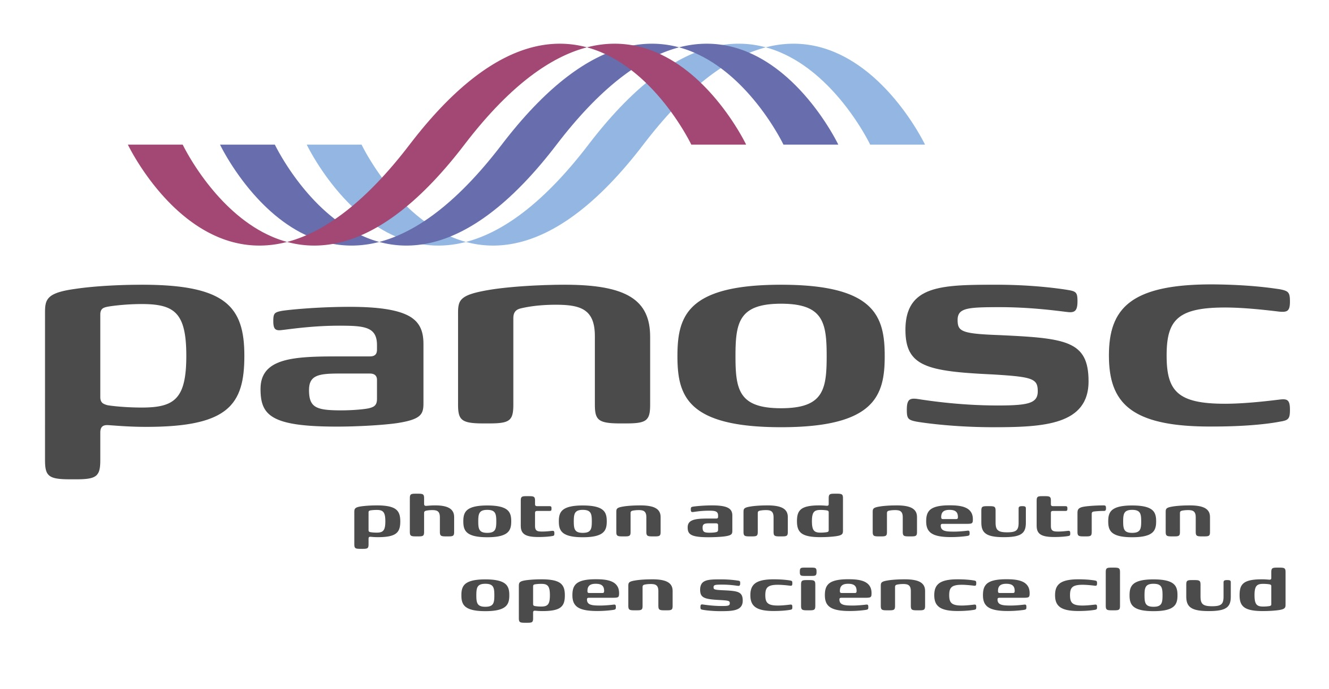

**Deliverable: D1.6 Report of annual workshop 2**

# Project Deliverable Information Sheet

|  |  |
| --- | --- |
| Project Reference No. | 823852 |
| Project acronym: | PaNOSC |
| Project full name: | Photon and Neutron Open Science Cloud |
| H2020 Call: | INFRAEOSC-04-2018 |
| Project Coordinator | Andy Götz (andy.gotz@esrf.fr) |
| Coordinating Organization: | ESRF |
| Project Website: | www.panosc.eu |
| Deliverable No: | D1.6 |
| Deliverable Type: | Report |
| Dissemination Level | Public |
| Contractual Delivery Date: | 30/11/2020 |
| Actual Delivery Date: | 02/12/2020 |
| EC project Officer: | René Martins |

## Document Control Sheet

|  |  |
| --- | --- |
| **Document** | Title: Report of annual workshop 2 |
| Version: |
| Available at: |
| Files: |
| **Authorship** | Written by: Jordi Bodera Sempere |
| Contributors: Rudolf Dimper, Andy Götz, Tobias Richter, Sandor Brockhauser, Carsten Fortmann-Grote, Jean-François Perrin, Ornela de Giacomo, Thomas H. Rod, Florian Gliksohn and Nicoletta Carboni |
| Reviewed by: Rudolf Dimper |
| Approved: Andy Götz |

## List of participants

|  |  |  |
| --- | --- | --- |
| **Participant No.** | **Participant organisation name** | **Country** |
| 1 | European Synchrotron Radiation Facility (ESRF) | France |
| 2 | Institut Laue-Langevin (ILL) | France |
| 3 | European XFEL (XFEL.EU) | Germany |
| 4 | The European Spallation Source (ESS) | Sweden |
| 5 | Extreme Light Infrastructure Delivery Consortium (ELI-DC) | Belgium |
| 6 | Central European Research Infrastructure Consortium (CERIC-ERIC) | Italy |
| 7 | EGI Foundation (EGI.eu) | The Netherlands |

# Table of Content

Project Deliverable Information Sheet 2

Document Control Sheet 2

List of participants 2

Table of Content 3

Introduction 4

Executive Summary 5

Summary of the annual meeting 6

ExPaNDS - PaNOSC Annual Meeting - 10th and 11th November 2020 9

1st day of the Annual Meeting - 10/11/2020 9

WP1/WP1 - Management 9

WP2/WP2 - Enabling FAIR 9

WP3/WP3 - PaN (meta)data catalogue services 10

WP4/WP4 - PaN data analysis services 11

WP5 - Virtual Neutron and X-ray Laboratory 11

2nd day of the Annual Meeting - 11/11/2020 11

WP6/WP1 - EOSC Integration 12

WP7/WP1 - Sustainability 12

WP8/WP5 - Training 14

WP9/WP6 - Dissemination and Outreach 14

Wrap-up 15

PaNOSC status 16

Summary of progress 16

WP1 - Management 16

WP2 - Data Policy and Stewardship 16

WP3 - Data Catalog Services 17

WP4 - Data Analysis Services 17

WP5 - Virtual Neutron and X-ray Laboratory 18

WP6 - EOSC Integration 18

WP7 - Sustainability 19

WP8 - Staff and User Training 20

WP9 - Outreach/Communication and Dissemination/Impact 21

PaNOSC Executive Board Meeting - 09/11/2020 23

Next steps 24

Appendix I: Wrap-up main points and feedback / discussion 25

# Introduction

This document is a summary of the PaNOSC[1] and ExPaNDS[2] Symposium and joint Annual Meeting that took place 9th, 10th and 11th November 2020. The management boards of both projects decided to organise a joint event in Prague hosted by ELI[3]. Due to the travel and health restrictions of the COVID-19 pandemic, the event was organised as a fully remote event.

To complement the report on the annual meeting, a brief report from the Executive Board meeting, which took place just before the symposium, and the progress from all work packages is also included.

# Executive Summary

PaNOSC is funded by the H2020-INFRAEOSC-04-2018 call with Grant Agreement Number: 823852. The project started on 1st December 2018 and has been running now for approximately two years.

Overall the project is advancing according to plan as attested by the recent Periodic Report and Project Review Meeting, with only minor delays. Partners and stakeholders are meeting regularly to move the project forward and deliverables are being submitted on time. Cooperation with ExPaNDS is increasing and the joint annual event is a testimony of this.

# Summary of the annual meeting

The European Photon and Neutron EOSC[4] Symposium open event took place on 9th November 2020, which was followed by the PaNOSC & ExPaNDS Annual Meeting on 10th and 11th November.

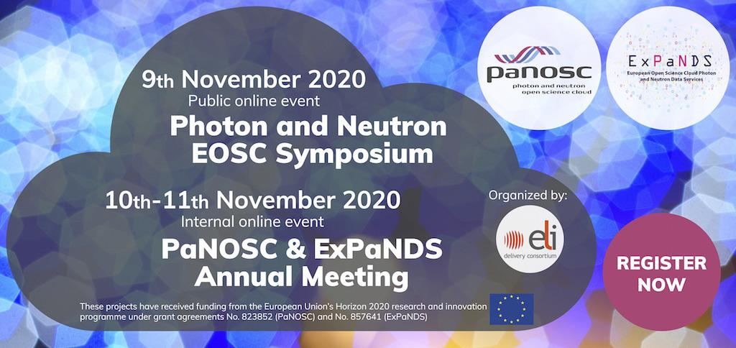

Figure 1: Joint event banner

The event was organised by PaNOSC and ExPaNDS in order to share the work that both projects are doing together and to push forward the collaboration between the projects. The event hosted by ELI was originally planned to be a traditional face-to-face event in Prague, however the COVID-19 pandemic forced the event to go online.

While online events on one hand make informal communication and joint work sessions more difficult, they on the other hand allow more participants to attend, especially persons interested in the projects but not necessarily taking part in them. In total, 215 persons registered to attend the events.

All the presentations and slides for both the Symposium and Annual Meeting are available on the PaNOSC GitHub repository:

* PaN EOSC Symposium: <https://bit.ly/PaN-EOSC-Symposium-2020-Presentations>
* 2nd annual meeting:<https://bit.ly/PaNOSC-2nd-Annual-Meeting-Presentations>

The Symposium was an open half-day event that took place during the afternoon of Monday 9th November 2020. The event was open to anyone that would register (at no cost) and we had over 140 attendees.

The agenda was as follows:

|  |  |  |
| --- | --- | --- |
| Topic | Speakers | Schedule |
| Welcome addresses by hosts and organizers | Florian Gliksohn and Kat Roarty | 13:00 - 13:15 |
| ExPaNDS and PaNOSC: perspectives for future services to users | Andy Götz, Patrick Fuhrmann and moderated by Sophie Servan | 13:15 - 14:30 |
| Coffee break | | 14:15 - 14:30 |
| Perspectives for the Photon and Neutron communities in the next phase of EOSC | Rudolf Dimper (Moderator),Tiziana Ferrari, Jan Hrušák, Rupert Lück, Christian Cuciniello | 14:30 - 15:45 |
| FAIR from a user perspective | Brian Matthews (Moderator), Susan Daenke, Filipe Maia | 15:45 - 16:45 |
| European Photon and Neutron EOSC Symposium : Wrap-up | Florian Gliksohn, Andy Götz and Patrick Fuhrmann | 16:45 - 17:15 |

The event started at 13:00 with some remarks by Kat regarding how the symposium was organised and the best way to interact with the speakers to make contributions or raise questions.

This was followed by a brief welcome address by Florian Gliksohn.

The first session of the day was an introduction by Andy Götz and Patrick Fuhrmann focusing on the basics that would help attendees external to the project to better understand the domain and topics covered. The presentation thus included an explanation of what are Research Infrastructures, different photon (synchrotrons, free-electron lasers and lasers) and neutron (reactors or spallation) sources, the different scientific domains that these research infrastructures can support, the challenges managing the data volumes, FAIR[5] data, the EOSC, PaNOSC, ExPaNDS and how the projects focus on delivering real use-cases for scientists of the photon and neutron communities.

This first session was followed by the *Perspectives for the Photon and Neutron communities in the next phase of EOSC* session. This session was moderated by Rudolf Dimper (former head of division at the ESRF and first chair of the PaNOSC Executive Board) and started with a 10-minute long presentation by each of the panellists:

* Christian Cuciniello (Project Officer for ExPaNDS)
* Tiziana Ferrari (Director of the EGI Foundation)
* Jan Hrušak (Chair of ESFRI and chair of the EOSC Landscape Working Group)
* Rupert Lueck (Head of IT at EMBL member of the EOSC Executive Board and co-chair of the EOSC Sustainability Working)

Rudolf Dimper as the session’s moderator asked the following questions to the panellists:

1. What is EOSC's scientific case? In other words, what is added value one should expect from EOSC from a scientific perspective? What should then be in your view the relevant metrics to assess the success of EOSC in this respect?
2. The Iron Lady (recently renamed to “Fair Lady”) document includes the following statement: "data preservation on large scales is often organised by long-term international projects and organisations making use of services provided at institutional, regional and national levels". Then, the following is also stated: "The EOSC Executive Board recognises that the availability of long-term data preservation services represents an important added-value for EOSC but responsibility for the curation and management of datasets must remain with the communities." Why this choice? Long-term preservation of data is a key area of concern for ExPaNDS and PaNOSC. Will researchers be able to access IT resources across borders for open science? How will access to resources be regulated (e.g. peer-review)?
3. ExPaNDS and PaNOSC as other cluster projects are supporting the adoption of FAIR practices of large communities by defining services that will be provided within the EOSC environment. What is the sustainability model for those services? What is the role for the Science Clusters beyond their project duration in liaising with the EOSC Association and the Commission? What should be the contribution of RIs in this context?
4. What funding mix do you imagine for EOSC in the future? What should be the contributions and complementarity of the EC and Member States respectively?

Questions from the attendees were then selected and addressed by the panelists. Questions covered the following topics: the EOSC Association, GAIA-X relationship with the EOSC and long-term sustainability and funding for the EOSC initiative.

## ExPaNDS - PaNOSC Annual Meeting - 10th and 11th November 2020

The Annual Meeting during the second and third day focused on the different Work Packages (WPs) and how both projects are collaborating at WP level.

### 1st day of the Annual Meeting - 10/11/2020

The agenda for the first day was:

|  |  |  |
| --- | --- | --- |
| Topic | Speakers | Schedule |
| WP1/WP1 - Management | Sophie Servan,  Jordi Bodera | **09:00-09:40** |
| WP2/WP2 - Enabling FAIR | Andy Götz,  Brian Matthews | **09:50-10:30** |
| Coffee break | | **10:30-10:50** |
| WP3/WP3 - PaN (meta)data catalogue services | Alun Ashton, Tobias Richter | **10:50-11:30** |
| WP4/WP4 - PaN data analysis services | Anton Barty,  Sandor Brockhauser | **11:40-12:20** |
| WP5 - Virtual Neutron and X-ray Laboratory | Mads Betelsen | **12:30-13:00** |

### WP1/WP1 - Management

Sophie and Jordi presented how both work packages cooperate and the main upcoming tasks that both work packages will be executing together:

* Common KPIs for both projects, to be agreed and published
* Risk management review and update, helping each other project in the review and assessment of risks
* Common and complementary items of work for each WP
* Updating the project's DMPs
* Open access publications

A brief discussion followed, with attendees sharing their desires to:

* Try to use a single chat-like tool for communication (Mattermost or Slack or other)
* Organise content for contributors differently, so it is easy to get started, learn the basics and obtain information about project's contacts

### WP2/WP2 - Enabling FAIR

Andy Götz (PaNOSC Coordinator and WP2 leader) presented the work package on Data Stewardship. The need for data stewardship and the progress up until now was rapidly reviewed. This included the publication of the Data Policy framework updated to take into account the experience gained by the partners who have already implemented a data policy and include the FAIR principles. The next step is to apply the changes to the data policies at each of the partner sites. This requires each site to identify the points in the PaNOSC framework that are missing from their data policy and propose them to management and the scientists to be included in an updated data policy. For those sites that do not have a policy, work is in progress to adopt one based on the PaNOSC framework. Currently the main work in WP2 is the specification of the Data Management Plans needs for each institute. Once these are finalised then ESS will start implementing a DMP template. Each site will then include this in their workflow. The difficulties of making DMPs useful for scientists and dynamic were discussed. This activity is being carried out together with HZB and ExPaNDS. PaNOSC will deliver an implementation of the deliverable in 12 months. ExPaNDS have a DMP activity due in 12 months too. The other main activity are the Guidelines for implementing a Data Policy. This deliverable will be based on the best practices and feedback gathered in the first 12 months of the project from the partners who had already implemented a data policy. The deliverable is due at the end of November 2020. The guidelines will cover at least the following point:

* Interacting with scientists + management
* Data catalogue solutions
* Data portal needs
* Long term archiving
* Metadata standards
* Standard techniques
* Electronic logbooks
* Digital Object Identifiers
* ORCID user IDs
* Processed data

Andy presented the ongoing activity at ESRF to have their data catalogue certified by CoreTrustSeal. WP2 is working with the CommDat committee of the IUCr crystallography union on data policies and data preservation. It is important for the PaNOSC and ExPaNDS partners to adopt community standards like the Golden Standard for macromolecular crystallography. Articles are going to be published in the IUCr Newsletter and Physics Today.

Brian Matthews (ExPaNDS WP2 leader) presented the work in ExPaNDS on enabling FAIR data and their interaction with PaNOSC. ExPaNDS has reviewed the current situation concerning data policies at the national level comparing RI policies with national policies. They have increased the awareness on FAIRness and held two online webinars on FAIR and the implications for users of the photon and neutron sources. The webinars were successful in attracting a large audience. The steps to making data from facilities FAIR compliant require FAIR policies, FAIR guidelines, FAIR tools and FAIR experiments. ExPaNDS have published a draft policy framework for the PaNs. The goal is to have a common approach to data policy for all PaNs together with PaNOSC by August 2021. ExPaNDS is working with the other INFRAEOSC-5b projects on FAIR metrics and tools. ExPaNDS is exploring extending Persistent Identifier services (PIDs) to visits and even datafiles similar to PaNOSC goal of PIDs for instruments. The EOSC PID policy is being closely followed and will be adopted where possible. ExPaNDS next deliverable on FAIR Guidelines will complement the PaNOSC guidelines on implementing data policies. ExPaNDS like PaNOSC is promoting the adoption of Nexus/HDF5 as standard. ExPaNDS is working together with PaNOSC on DMPs.

### WP3/WP3 - PaN (meta)data catalogue services

For data catalogues (WP3) the two work package leaders Alun Asthon (ExPaNDS) and Tobias Richter (PaNOSC) jointly presented. They introduced how data catalogues are or can become an integral part of the science workflow at photon and neutron facilities and how they also can be set up as a gateway to EOSC services. They also discussed the benefit to both the original experimental team, that enjoys privileged access during the embargo period, and to interested third parties from the wider community. The main part discussed how the work in both WP3s aligns with two corresponding use cases. To cater for PaN facility users in general and often the data creators PaNOSC has led the development of a common search API. This will be implemented by all partner facilities, will enable highly specific searches and can honour access privileges. To curate the datasets in a consistent way work is ongoing to develop common dictionaries (ontologies) for the most relevant search expressions. The second use case covered caters for the wider science community. To give PaN datasets visibility outside of the domain this second approach is to offer metadata to EOSC data repositories, like B2Find and OpenAIRE. These external repositories will crawl registered data providers, copy and index the metadata. They then aim to become interdisciplinary hubs for searching for datasets. The presentation ended with a summary of the plans and the current status of activities.

### WP4/WP4 - PaN data analysis services

Anton Barty (ExPaNDS WP4 leader) presented the general aim of supporting the scientific community with a data analysis platform which can support not only searching for data, but immediately its visualisation and analysis. He also performed a demo showing a use case of checking the progress of figure of merit along the processing of a dataset from a serial crystallography experiment. Sandor Brockhauser, the WP4 leader in PaNOSC then summarised the current activities and achieved results and how they are presented by the KPIs 4.1.1-4.1.3. He has highlighted how all the developments (Remote Desktop and Jupyter microservices, software tools for data visualisation and analysis) are concentrated around a central project of creating a portal for each facility which can be then federated by a central PaNOSC portal made available to EOSC. At the end, Michael Schuh from DESY (EGI partner) presented a demo of the PaNOSC portal and has explained its integration to the cloud environment.

### WP5 - Virtual Neutron and X-ray Laboratory

Mads Betelsen presented the work performed on simulation in PaNOSC. The simulation packages SimEx, Oasys and McStas/McXtrace are all used extensively for design of instrumentation and to evaluate feasibility of experiments. It was described how each of these simulation packages is being exposed as an online service, which is mainly done through Jupyter Hubs, except for Oasys that use remote desktop. Furthermore, details on libpyvinyl were shared, this package will serve as a template for interface and structure for simulation packages by providing base classes. The user experience when using a package based on libpyvinyl will then be similar to SimEx, and it was shown McStasScript (python API for McStas) can be used in this way. As such, libpyvinyl will both act as a starting point for new simulation packages, and ensure that the user experience is similar for the python based simulation tools.

Work from each partner institute was presented, showing both how each simulation package is being used for scientific work and what new features are being developed. The strong connection to the e-learning work packages were noted, and as the simulation packages are now deployable as online services, this collaboration can start in earnest.

In terms of feedback from the audience, it was suggested that an effort should be made to distribute the software to a wider user base, both to spread awareness but also to get feedback from the user community.

### 2nd day of the Annual Meeting - 11/11/2020

The agenda for the first day was:

|  |  |  |
| --- | --- | --- |
| Topic | Speakers | Schedule |
| WP6/WP1 - EOSC Integration | Jean-François Perrin,  Patrick Fuhrmann | **09:00-09:40** |
| WP7/WP1 - Sustainability | Ornela de Giacomo,  Mirjam van Daalen | **09:50-10:30** |
| Coffee break | | **10:30-10:50** |
| WP8/WP5 - Training | Nazaré Guimard, Thomas Rod | **10:50-11:30** |
| WP9/WP6 - Dissemination and Outreach | Nicoletta Carboni,  isabelle Boscaro-Clarke | **11:40-12:20** |
| Wrap-up | Andy Götz | **12:30-13:00** |

### WP6/WP1 - EOSC Integration

Regarding WP6, Jean-François Perrin presented the achievements and ongoing developments on behalf of the WP6 team. The presentation was prepared during the fortnightly team meetings and reviewed by all the partners. The four main topics: AAI, Data Transfer, EOSC integration and the community software catalogue were covered by the 20mn presentation. The current status of the WP is reported in more details in the PanOSC WP6 status section later on in this document.

Discussions focused mainly on:

* the need to organise a dedicated training on AAI technologies for the community. This training will cover: protocols (SAML and OIDC), the setup of a standard SSO linked to the UmbrellaID infrastructure (the will be an hands on session on setting up the keycloak solution) and the implementation of authorisations. This training session will last 2 days and is currently targeted for February 2021. It should allow the whole PaN community service providers to be at ease with the solution.
* the need to organise a workshop with our colleagues from the ESCAPE project who are developing a data lake solution. Despite the fact that the communities are extremely different in their approach to IT solutions and organisations, the use cases seem sufficiently similar to investigate more deeply collaboration opportunities. A workshop between PaNOSC, ExPaNDs and ESCAPE has been agreed and will be organised in January 2021.
* the request from advanced users to have a standard interface for accessing compute resources from different providers. This need has been generally acknowledged. A first response was that in the community including EGI, OpenStack CLI and APIs seem to be a standard but more investigation is needed.

The session was well attended by more than 100 participants for PaNOSC and ExPaNDS, the whole PaN community interested in WP6 topics has been invited to join the mailing list wp6@panosc.eu

### WP7/WP1 - Sustainability

Ornela and Mirjam showed the progress in the activities related to Sustainability in the last year, in each of the projects and introduced the common actions to be developed in collaboration between ExPaNDS and PaNOSC. While ExPaNDS has focused more on non-cost related aspects of the sustainability, as reflected in their deliverable D1,7 “Sustainability Policy Report”, PaNOSC has focused more in the cost analysis, with the aim of addressing the other sustainability related aspects in the sustainability report, at the end of the project. PaNOSC is about to complete the cost collection for a series of services offered to the user community related to the provision of FAIR data (facility operation) and the link to the EOSC (e.g. re-usability of data), as in the following picture:

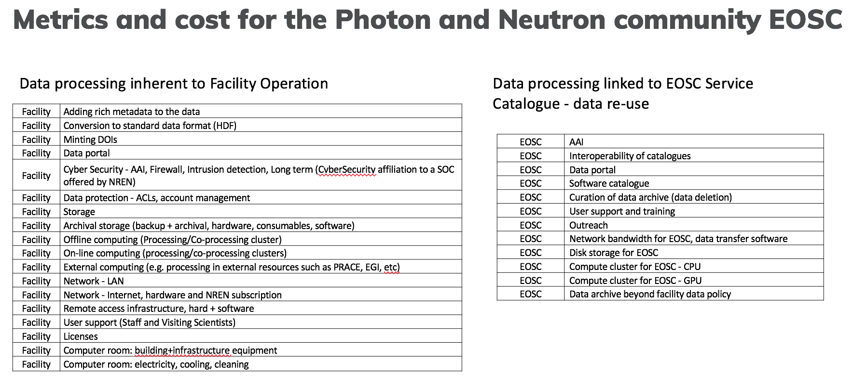

Figure 2: Metrics and cost for the PaN coummunity EOSC

Moreover, in the framework of task 7.3, business models, the partners are working in the definition of the elements of the canvas chosen for the development of the PaNOSC business model/s:

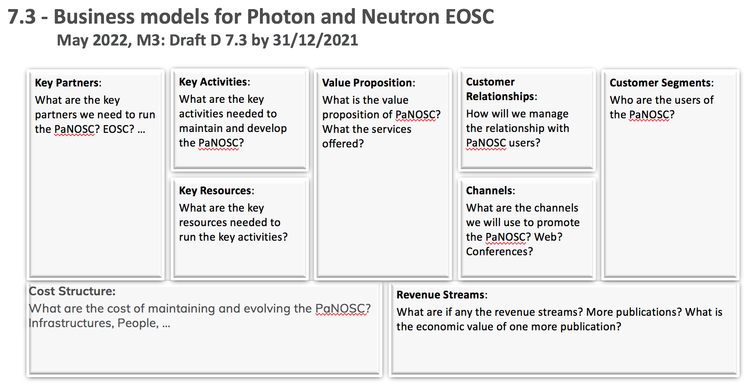

Figure 3: Business models for PaN EOSC

Partners are also considering to adopt the platform business model approach used by the Sustainability WG of the EOSC secretariat for the presentation of the business plan for the MVE. There could be advantages in using the same representation (easier comparison, familiarity) but this will be decided by the WP when the final version of the Iron Lady document, including the business model, will be published.

PaNOSC and ExPaNDS have agreed to collect a series of indicators related to the EOSC liaison and to develop a mechanism to coordinate the feedback of both projects to any requested input as a single one, whenever the positions will be aligned.

### WP8/WP5 - Training

Thibaud Cayla, who is the work package leader for ExPaNDS WP5, presented a joint report for ExPaNDS WP5 and PaNOSC WP8 on behalf of the WP leaders and co-leaders for these two work packages. The work packages work jointly on identifying existing or developing new training material and organizing training events. In addition to this, PaNOSC WP8 is also working on an e-learning platform, pan-learning.org, which is being developed with conceptual input and support from ExPaNDS.

The work packages have weekly joint progress meetings with participants from all the PaNOSC partners and some ExPaNDS partners. In parallel to these meetings, weekly meetings focusing on the technical development, primarily of pan-learning.org, are also taking place. In these meetings, participants from the PaNOSC partners ESS and ELI, and the ExPaNDS partner HZDR participate.

A FAIR training workshop has been organized by ExPaNDS, targeting instrument scientists and other facility staff. 115 and 87 persons participated on Day 1 and 2, respectively. During the presentation, a call for participants to a ‘Train the Trainers’ workshop beginning of 2021 was also announced. In this workshop, staff will be trained in developing training material for pan-learning.org, while also developing training material for some of the deliverables in the work packages. The ambition is that each facility will appoint a ‘training champion’.

Development for pan-learning.org is progressing. Integration of Jupyter is well underway, as well as federated authentication and authorization.

The ambition is to provision a training portal with three components: 1) catalogue of courses and training material of relevance for the photon and neutron scattering community, 2) a calendar with training events, and 3) the e-learning platform, pan-learning.org.

Thoughts about sustainability of the services developed in the training work packages were also discussed, and led to a subsequent discussion on how to link up with the community initiatives and associations LENS, LEAPS and Laserlab-Europe. Jonathan Taylor suggested forming a joint LENS-LEAPS IT working group, and that idea is now brought forward to the LENS and LEAPS management.

### WP9/WP6 - Dissemination and Outreach

Nicoletta, Isabelle and Kat presented the work carried out for the external communication and dissemination of PaNOSC and ExPaNDS goals, activities and results in the past year, and gave an overview of the joint roadmap, including the following:

* Regular cross-grant communication
* External communication

Produce and distribute promotional material of our main projects achievements; WPs by promoting their activities; Mutually support communications via our social media channels; Mutually support the promoting of our initiatives, events and training material/activities; Enhance interactive participation of the audience attending our events, and monitor performance.

* User Engagement

Target user meetings more widely; Identify and attend other events and conferences targeting users; Engage with user offices across PaN facilities; Identify and collect user success stories at PaN facilities and publish these use cases; Organise user-centric workshops / meetings (training WPs) and attract participants from the PaN community; Promote and distribute demos / videos on the services developed; Present progress and achievements at our partners scientific board meetings; Promote services and policies via PaN networks (lightsources.org, neutronsources.org, etc.).

* Collaboration with other EOSC-related projects:

Ensure all cluster projects attend our Annual Meeting and that we attend theirs; Invite 5b-cluster project representatives to all our workshops / events; Active participation in the EOSC Secretariat's interest group "EOSC Cluster Collaboration" meetings, and related joint actions; Periodical meetings with cluster projects and communications/dissemination of the set actions and results achieved.

A brief discussion followed, with attendees sharing their desires to:

* Identify a solution for an online forum to exchange questions/answers on topics of common interest, to be eventually included on PaNOSC/ExPaNDS websites;
* Improve communication to, and increase the involvement of PaN facilities managers/directors.
* Support the collection and publication of use cases;
* Improve connection to the facility users, and publish interviews to collect their feedback on FAIR open data and PaNOSC/ExPaNDS services;
* Support PaNOSC WP7 in its communication to stakeholders;
* Find the most suitable platform to release an OA publication on the outcomes of the annual meeting.

The partnership has been informed that WP9/WP6 will prepare and distribute a survey to WP leaders, to ask for feedback on the two WPs performance and suggestions for further actions to increase the WPs’ impact.

### Wrap-up

The wrap-up session, chaired by Andy Gotz and Patrick Fuhrmann, allowed to obtain information from the discussions of each of the previous sessions and was analysed briefly by each WP leader. A large number of questions and comments (see appendix) were addressed for each WP.

The main conclusion was that PaNOSC and ExPaNDS are collaborating in many areas and they need to continue reinforcing their collaboration. Where there are common WPs, namely WP1, WP2, WP3, WP4, WP8, and WP9 collaboration is happening naturally but it is more challenging for WP6 and WP7 because ExPaNDS does not have an equivalent WP. Holding a common Annual Meeting was very useful for bringing the PaN community together and must be continued in the future. The Symposium was a good way of sharing our common vision with external partners and a way of exchanging views with the EOSC and EC representatives. The PaN community needs to address the many challenging issues on data management together. Andy proposed to do this by creating PaNdata committee made up of representatives of the PaN sites which will continue the work of PaNOSC and ExPaNDS after the two projects end. This could be done under the auspices of LEAPS and LENS or independently together with other standards bodies like IUCr.

The hosts, ELI-DC, and the organisers of the symposium and annual meeting were thanked for their excellent organization of the two events. The coordinators sincerely hoped that the next time a face-2-face meeting will be possible to allow more technical discussions and work, and last but not least social interaction, to happen!

# PaNOSC status

## Summary of progress

PaNOSC is now half-way through, has been submitting deliverables on time and has completed successfully the periodic report and review meetings.

Feedback received from the European Commission has been mostly positive and where improvements have been suggested the project has started to implement them.

As the project matures the importance of the deliverables and milestones increases and it is required that all partners and contributors of the project remain focused to ensure a successful delivery and prepare for sustainability of the project outcomes in the years to come.

### WP1 - Management

The WP1 has continued to organise bi-weekly Project Management Committee (PMC) meetings, the agenda and minutes of which are available in GitHub[6].

The management WP has also been heavily involved in the organisation and rehearsal of the review meeting and in the organisation and submission of the periodic report. Following the feedback from the review meeting, the WP leadership has started to plan actions addressing the feedback received.

Furthermore, the WP initiated a review of project expenditure per partner and WP, the findings of which were presented during an extraordinary PMC meeting and the Executive Board meeting. The WP will be monitoring the implementation of several actions that the partners committed to implement following this internal review.

### WP2 - Data Policy and Stewardship

WP2 has gathered feedback and best practices from all partners who have implemented a data policy at their site (ILL, ESRF, EuXFEL, ESS, CERIC-ERIC) and published it on Github. The next deliverable will expand on this document to produce a set of guidelines.

The PaNdata data policy has been updated together with the ExPaNDS project members to include the experience gained after almost 10 years of experience with PaN data management and to address the FAIR principles. The updated data policy has been released as a deliverable D2.1.

The requirements for each site concerning Data Management Plans have been gathered and will be used to implement DMP templates over the next 12 months.

PaNOSC WP2 has participated in the EOSC related activities on FAIR as well as the FAIRsFAIR repository certification process.

### WP3 - Data Catalog Services

Aligning activities has become harder with the current travel restrictions. However, partners have managed to keep up a reasonable pace to deliver on the WP3 objectives. For pushing data out to third party repositories the WP selected OAI-PMH as the common endpoint to provide. B2Find and OpenAIRE have been selected as main targets to register with. Discussions with B2Find are very fruitful and may lead to some customisations in the metadata schema. Only few have met all prerequisites for success. Some lack public data, others work on the implementation of the service and others are working with providers to achieve a correct mapping and recognition of the metadata.

Deliverable D3.1, the baseline version of the common search API, was submitted and describes domain specific queries. The release followed a series of preparation meetings that included a wide representation from ExPaNDS facilities, that committed to the same goals of implementing that API at their institutions. PaNOSC partners have started implementing this API for their catalogues and ESS already has a running version. At the moment work is ongoing to develop both a test case to verify the compliance of the local implementation with the specification as well as to provide the demonstrator to federate the services into a central search hub. This one-stop-shop is developed collaboratively with WP4 and can be part of a data portal.

In addition to these activities, mainly of software development and deployment, the WP has also made progress to narrow down the search terms. The API defines a rough data model of filtering options in searches, like experimental technique, experimental parameters and involved personnel. To make this work in practice the facilities need to agree on common labels and terms, which need to be understood by the implementation of the search and mapped onto the appropriately curated datasets. A task force is working on labeling the techniques in a uniform way. The expression of other metadata information will follow suit.

### WP4 - Data Analysis Services

WP4 continued the [regular biweekly meetings](https://github.com/panosc-eu/panosc/tree/master/Work%20Packages/WP4%20Data%20analysis%20services/Meetings) and have achieved the milestone MS4.1 at M18 as planned. This milestone was directly linked to the second deliverable D4.2 on a prototype for Remote Desktop and Jupiter services. Working prototypes have been demonstrated for both of these data analysis platforms planned to be offered for PaNOSC/EOSC users.

Parallel to these activities, WP4 continued developments with the involvement of the scientific user community to create or customise tools that can be of use for data analysis and visualisation. With the interaction to the user community, it has become clear that a data analysis portal will only be useful if it provides the scientists with access to their own data and covers not only the publicly available datasets but also those still under embargo. This finding brings a new complication to the portal development because the user must not only be authenticated, but also additional connections must be developed to the authorisation framework of each facility.

During the year, WP4 designed the architecture of the PaNOSC portal which included data search capabilities to be supported by WP3. Next to developing the architecture, WP4 also made a [skeleton implementation](http://panosc.apps.okd2.ceric.fedcloud.eu/) which could already be installed on EGI’s federated cloud (resources from DESY and CESNET) and has been demonstrated at the PaNOSC /ExPaNDS Annual Meeting in November 2020.

As a result of the active software developments in WP4 and 5, an additional 14 tools have been added to the [PaNdata software catalogue](https://software.pan-data.eu/). Note that the WP is still working on these tools and their integration into the portal.

WP4 KPIs have been measured at M18 and they all show a stable progress:

* KPI 4.1.1 (Percentage of facilities offering JupyterHub or remote desktop for analysis services) has moved from 67% (after M12) to 100%.
* KPI 4.1.2 (Number of unique users making use of JupyterHub or remote desktop for analysis services at partner facilities) has increased from 158 (M12) to 269.
* KPI 4.1.3 (Number of techniques available through remote services) as the last indicator also increased from 8 (M12) to 49.

In the next year, further improvements are expected for the last two KPIs showing the coverage of scientific techniques and research communities. An immediate goal is to support the integration of WP3’s dataset search capabilities with the portal and so enabling the data analysis and on the fly visualisation services on the datasets selected by the user. This requires also an active involvement of WP6 and connecting the AAI capabilities of the portal to the facilities providing the hardware resources.

### WP5 - Virtual Neutron and X-ray Laboratory

WP5 has continued its weekly video meetings to monitor the progress and to facilitate the collaboration among RIs. Meeting notes are publicly available at <https://github.com/PaNOSC-ViNYL/ViNYL-project/wiki/Weekly-Meeting-Notes>. Moreover, two development sprints, held in April and in September 2020 ensured timely submission of Milestone 5.2 and Deliverable 5.2 which are due in November 2020. Milestone 5.2 documents demonstration of the various simulation services, delivered either Jupyter notebooks accessible in Jupyter Hub cloud instances at Eu.XFEL and ESS or remote desktop solutions like the Virtual Unified Office CERIC-ERIC. The corresponding simulation software APIs are released as D5.2. Among them is the new package libpyvinyl which serves as the top level simulation API baseclasses. By subclassing these base classes, our various simulation codes and their APIs become usable through the harmonized interface defined in libpyvinyl. The first simulation API to make use of this harmonization is McStasScript. Simex has followed the same design principles as libpyvinyl and will be adopted in the near future.

In parallel, we continued the development of simulation data formats in the form of openpmd standard extensions.

### WP6 - EOSC Integration

During this year we have specially focused the activities on the three data transfer use cases and the deployment of the community AAI (UmbrellaID) on the new eduTEAM infrastructure.

The data transfer use case related to the archival of data in a remote data centre is now considered closed. The rclone solution was selected after testbeds where FTS, GridFTP and Ruccio were also explored as potential solutions. For this relatively simple use case rclone had the advantage to provide in a single package all the necessary tools (transfer and simple catalogue) for answering the use case need. The two other use cases are still investigated. Solutions have been identified such as OneData for the transparent transfer of data from RI archives to EOSC compute resources or Globus for the RIs’ users driven data transfer use case but they are still in a final deployment stage for being tested at large scale.

Regarding the AAI, the new infrastructure has been rolled out on GÉANT servers and has been progressively used following the Service Providers (SP) migrations. As of today, 90% of the SPs have been migrated. The SP migration will be completed by the end of the year allowing us to move to the second phases of the project where users will be able to join the federation using different Identity Providers (IdP) such as their home organisation IdPs through eduGain or ORCID. We will also enrich the set of user metadata available for the services with standard ones like email address, orcid, affiliation.

We are currently registering the two initial services in the EOSC portal, it will serve to get an initial understanding of the processes and requirements that will be useful for registering the whole set of services that the PaNOSC WP will deliver.

Concerning the PaN software catalogue, a survey for improvement or new functionalities was launched at the beginning of 2020 and requirements from the whole community has been collected. The developments were planned to be started in spring but the covid crisis has slowed down the recruitment process and delayed the work, the rollout of the development is now programmed for summer 2021.

### WP7 - Sustainability

WP7 has developed a detailed work breakdown structure to allow the coordinator an easier follow-up of the activities of the WP and assign milestones, with the agreement of the partnership on the targets. All the tasks of the WP have been initiated and more personnel from different facilities has been involved. ELI added an IT expert to the team with an excellent overview of the project, therefore extremely helpful. The partners that were less active in the first 18 months have been participating regularly in the meetings and contributing to the activities. CERIC involved a business specialist to contribute to the development of the business models. The collection of costs achieved its maturity after three iterations, each one adding to the uniformity of the exercise and the capability of the model to represent similar items for all the facilities. The partnership was aligned on the scope of the business model and started working on the definition of the elements of the canvas. In parallel, other approaches (like the platform business model) are being considered. The WP members discussed the following steps to lead the WP to deliver and created a work breakdown structure that is publicly available in Github:

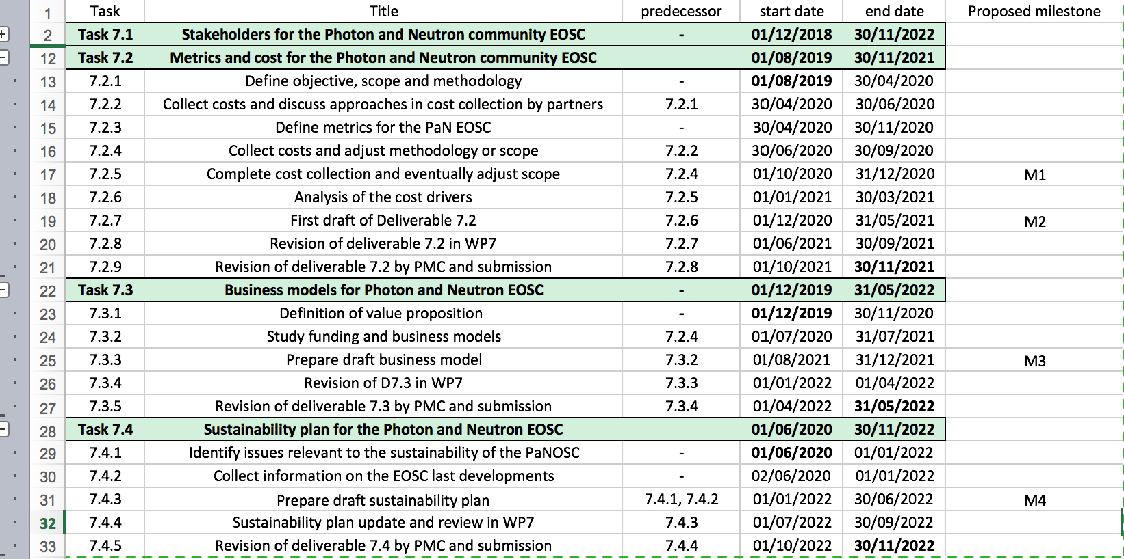

Figure 4: task breakdown for WP7

Any change made to the work breakdown will be reflected there.

As seen in the breakdown, the upcoming milestone is the complete cost collection within December. This will allow us to perform the analysis of the main cost drivers and all this will feed into the business model. The most general aspects of the business models (value proposition, channels and customer segments are being developed) and in parallel the WP is focusing on the non financial aspects of sustainability, as complementary information to feed into the sustainability plan. The WP also established good links with the ExPaNDS project, since many of the sustainability issues faced by PaNOSC are shared with ExPaNDS. In the framework of the common activities, we have agreed to jointly liaise with the EOSC (e.g. providing coordinated feedback), keep track of a series of indicators in this area, share all the findings and work together on all aspects of common interest.

### WP8 - Staff and User Training

Technical meetings are now running on a weekly basis with participants from ELI and ESS. ExPaNDS is also represented at these meetings through HZDR. pan-learning.org is now hosted by ESS and with continuous integration (MS8.3). It is also possible to start a Jupyter instance from pan-learning.org (Task 8.2) but at this point in time without any further communication between Moodle and Jupyter. ELI is currently working on a solution to secure bi-directional communication between Moodle and Jupyter based on open source software from IllumiDesk. Collaboration with WP6 and GÉANT is ongoing in order to implement federated authentication and authorization based on KeyCloak and Umbrella. High-level discussions have started with ExPaNDS on how the underpinning architecture can best support the ambitions in both ExPaNDS and PaNOSC and long-term sustainability. The ambition is to have a training portal with three components: i) a training catalogue, ii) a training event calendar, and iii) an e-learning platform in form of pan-learning.org. In this regard, the ambition is also to remove the existing catalogue of external courses from pan-learning.org. Discussions are ongoing on how to sustain such a portal in the future, and hence, LaserLab, LENS, and LEAPS have been approached in order to ensure commitment from community organizations for having such a portal in place also beyond the lifetime of ExPaNDS and PaNOSC. Requirements for the training portal are currently being gathered from different perspectives; namely user experience (trainee and trainer), technical, sustainability, and legal perspective.

We have reviewed ELIXIR's training portal, TeSS (<https://tess.elixir-europe.org/>) in order to see if we can use their technical solution for our purpose and learn from their experiences. Thus, we had a meeting with the TeSS management team that was very helpful with sharing their experiences and lessons learned. This has helped us in focusing on getting ‘training champions’ appointed at each facility, who will act as point-of-contact for training activities at their facility and collaborate with the training work packages in ExPaNDS and PaNOSC. We envision that these champions will play a crucial role for the long-term sustainability of the training portal. It still remains to be seen to which extent we will be successful in getting these champions appointed. However, the first event for these champions will be the Train the Trainer’s workshop Task 8.4, which we currently are planning jointly with ExPaNDS and the teachers at that workshop. The purpose of the workshop is to train the participants, hopefully the champions, in how to use pan-learning.org and develop courses for it, as well as to develop hands-on courses for the platform. Specifically those that are deliverables in PaNOSC. Due to the COVID-19 pandemic, we will move the workshop online, and we currently plan the workshop for 3 + 2 days, with the first three days in January/February 2021 and the last two days in March/April 2021.

We are also collaborating with ExPaNDS on identifying existing training content with the photon and neutron scattering communities. That content will be used to seed the training catalogue.

In parallel with the weekly technical meetings, we also have weekly joint ExPaNDS and PaNOSC work packages meetings, where all of the above aspects are being considered.

On the staffing side, ESS has recruited a post doc who will start on January 4th, 2021, to work on the non-technical aspects in WP8, specifically tasks 8.3-8.7, i.e. getting content in the e-learning platform, in collaboration with ExPaNDS and the other work packages in PaNOSC. Indeed, the post doc will also work part-time on WP4 and WP5. ELI is currently considering how to best staff that effort. However, on the technical side, ELI has two more persons involved, where they are evaluating different architecture solutions for the training portal and working on integrating Jupyter.

### WP9 - Outreach/Communication and Dissemination/Impact

Following the PaNOSC review meeting in June 2020, and on the basis of the feedback collected from the partners and the review committee, WP9 has updated its yearly [communication and dissemination plan](http://bit.ly/PaNOSC-CommsDissemPlan-update2020), adding and further detailing a set of actions to better target stakeholders, with a particular focus on the user community. These include, among others, targeting PaN user meetings more widely; network with PaN user offices; collect, draft and distribute use cases of the services developed. In this respect, WP9 supported the development of the PaNOSC use case template, and contributed to the collection of use cases from the scientists at the partners.

The promotion of use cases is key also for other EOSC projects, to showcase the added value of the EOSC and to its main stakeholders, i.e. researchers. In addition, the cross-cluster discussion to increase the impact of the projects’ and their communication/dissemination is ongoing, facilitated by the EOSC Secretariat in the frame of the Interest Group for cluster collaboration, which also envisages to organize a set of EOSC-related thematic workshops throughout 2021.

In this context, WP9 steered the action to map key people in EOSC cluster projects in all domains (management, data policy and stewardship, data analysis / simulation, sustainability, training, communications, etc.) to enhance networking & collaboration, also among the technical staff:<http://bit.ly/EOSCclusters-keypeople>

WP9 has continuously taken care of curating the content of the website and its Twitter account, with updates on the project’s activities, events, milestones (e.g., WP4 OSCOVIDA, WP6 UmbrellaID integration with eduTEAMS, pan-learning.org online), deliverables (e.g., PaNOSC research data policy framework), and publications (both on the [PaNOSC page on Zenodo](https://zenodo.org/communities/panosc/), and on OA peer-reviewed journals). Such information has also been distributed via CORDIS and through project partners’ communications channels (website, social media, newsletters, mailing lists), as well as to the other EOSC projects, PaN European initiatives (LENS and LEAPS) and networks (lightsources.org, neutronsources.org).

New demos showcasing the features of the services developed in the technical WPs, and videos on the project and its achievements have been released on the PaNOSC Youtube channel, and promoted via Twitter and the PaNOSC website. As of 13 November 2020, both demos and videos reached nearly 1700 views. All PaN facilities in PaNOSC and ExPaNDS, and members of the LENS and LEAPS initiatives, have been actively involved in a video project sponsored by PaNOSC and coordinated by WP9, which ended up with the release of [“The DOI for data” video](https://bit.ly/The-DOI-for-Data) in August 2020, which has upgraded the version previously produced in the frame of the FILL2030 H2020 project.

In early September 2020, PaNOSC videos have also been displayed at the ERF-AISBL booth at the Science in the City Festival targeting the general public at ESOF2020 in Trieste.

The presentation to stakeholders of PaNOSC goals and achieved results is strategic, to increase the knowledge about the benefits of the EOSC and of the services and technologies developed by the project. In this respect, WP9 supported PaNOSC contributors by providing visuals and posters for their presentations, and by promoting their talks scheduled at events for policy makers, IT professionals and the scientific community. Moreover, in October 2020, a [digital brochure](https://bit.ly/PaNOSCbrochure2020) on the project’s progress and main accomplishments in the first 18 months of implementation, was published on both PaNOSC website and Zenodo. Two summary posters giving a brief overview of the work done, have also been made available to the partners for their facilities.

WP9 leader has been taking part in the biweekly meetings with other WP leaders and the Project Management Committee. The WP also contributed to the organization and promotion of PaNOSC 2nd annual meeting, in coordination with WP1 and with ExPaNDS.

Last but not least, WP9 periodically monitors its performance through a set of KPIs, which have been recently updated to ensure alignment with WP6 (Communication & Dissemination) of our sister project, ExPaNDS.

# PaNOSC Executive Board Meeting - 09/11/2020

The Executive Board meeting took place in the morning of 9th November 2020, just before the EOSC Symposium was due to start.

The agenda was:

1. Review of progress and state of PaNOSC after 2 years
2. Use Cases and engaging with Users
3. Action plans per partner to address issues raised after internal project review
4. EOSC association
5. Nomination of new EB Chair
6. Topics to discuss with ExPaNDS
7. AOB

The Executive Board agreed to increase the focus on real use-cases from scientists and real users of the facilities, which will highlight the benefit of all the services that PaNOSC is setting up. If PaNOSC creates really useful and valuable services to the scientific community then its work will be easier to sustain in the future.

A brief discussion followed on actions to ensure the project remains on track, all partners contribute and we adapt to current circumstances.

The importance of the EOSC Association was also discussed, Mark Johnson (ILL) was appointed as the new Chair of the Executive Board and a list of points to discuss between Executive Boards of ExPaNDS and PaNOSC were shared.

# Next steps

The next two years of project execution will be challenging as all the building blocks of PaNOSC start to come together and complement each other. More importantly as services start to be available to users, the real impact of PaNOSC (and its sister-project ExPaNDS) will become visible. The project aims to collect use cases from scientists and RI users in order to ensure that the services made available to the PaN scientific community are the ones that provide the better value for the resources, time and budget available.

Collaboration with ExPaNDS will improve over the next two years, both projects working closely together while the feedback from the review meeting is implemented.

# Appendix I: Wrap-up main points and feedback / discussion

Here follows the feedback and comments collected for the wrap-up session of the Annual Meeting. Please note that the list has not been edited.

WP1/1 - Management

* Mattermost vs. Slack (vs Zulip) - choose one
* Make a landing page for recent starters with all links and who's who, to be associated with an onboarding briefing by WP9/6 (plus would be useful to have a bit of perspective on the wider EOSC ecosystem, e.g. task force groups, other 5b/ESFRI projects)
* See about mail history for new starters (legally complicated - tbc)
* Townhall meetings?

WP2/2 - FAIR

* Some people want FAIR and we should make tools available for them as a start (ex: zepto-second publication, Filipe's presentation) - for the others who resist we shouldn't insist
* Publishers pushing for FAIR is really invaluable, helping the cultural change
* DMPs - how to persuade instrument scientists/users to use them.
* DMPs - focus on benefit to users - and again focus on those areas which will gain the most benefit.
* DMPs - we would like to get more input from other sites. Add your input to this document : <https://docs.google.com/document/d/1LVJ0O95ZtqByk84TcyhdpMJYSLlFADNe8eIvNxUnJuU/edit?usp=sharing>
* Data Policy - groundwork for FAIR principles in Data Policies has been done but adoption in existing data policies still need to be done
* We (PaNOSC+ExPaNDS) would like feedback on which areas sites need guidelines for adopting and implementing a Data Policy
* Metadata - Nexus is the de facto standard but a number of techniques are not defined yet. Need to increase sharing of definitions, tools supporting, and helping scientists adopt / use Nexus
* We need to use the synergy of PaNOSC+ExPaNDS to promote domain specific metadata standards like Golden Standard and links to standards bodies like IUCr but others too
* Share examples and use cases.

WP3/3 - Data catalogues

* Nexus standardisation: adoption and making it standards
* OAI-PMH (B2FIND, OpenAire): only available for open data. However, the implementation could be tested using the OpenAire search Validator
* Why using rigid search API?
* Need AAI in the search API for it to be useful
* Discussion on Google Search and Google Dataset Search and schemas.org
* Should we be involved looking into schemas.org e.g. BioSchemas
* EOSC is asking us to look into DDI-CDI - does anyone know this tool / standard?

WP4/4 - Data analysis

* Portal development with data analysis/visualisation microservices
* Should try to make applications ‘cloud aware’
* Not all applications are cloud-friendly
* Both approaches should move closer towards each other, HPC should be more cloud-like and cloud should be more HPC-like
* MPI/GPU support on kubernetes/docker (singularity?) is pretty crucial, multi-node processing is also a requirement for some use cases
* Can’t really enforce how software is written/used by the scientists, so the implementation has to be flexible enough to support user-created code
* Would be useful to have a unified cloud-query API, allowing for integration with commercial cloud providers (e.g. multiple cloud providers already adopted AWS S3/EC2-like APIs for their services, Wasabi and Equinix Metal both use Amazon-like APIs)

WP5 - Simulation (PaNOSC specific)

* Need feedback from other workpackages, especially WP4 and WP8 (simulations will play an important part in e-learning)
* Provide necessary infrastructure to unite the services under one roof and provide access to WP5 members for CI/CD

WP6 - EOSC integration (PaNOSC specific)

* Most pressing: AAI, Services Provider transition to the new Umbrella ID infrastructure (eduTEAM) needs to be completed soon and will allow integration with EOSC solutions.
* Data Transfer: Rclone and Globus are definitely solutions for particular use cases. A more consolidated solution, maybe even merging the 3 use cases provided by WP6, would be beneficial, interaction with ESCAPE project is ongoing. OneData , the identified solution for the 2nd use case (i.e. transparent data transfer for compute services) still needs adjustments in order to be able complete the pilots with user acceptance tests.
* Common Registry: depends on clear added value/uses cases and sustainability model for PaN services. Needs a ‘caretaker’
* More management: here too we need to figure out how those common services can be sustained.

WP7/1 - Sustainability

* We should include the sustainability of open source software we rely on e.g. HDF5, Debian packaging, AAI UmbrellaId/EduTeams. This can be addressed by taking out a support contract with groups sustaining the software e.g. the following companies provide a paying service for the above packages HDF Group, commercial companies who package software, and GEANT respectively.
* We can benefit from a critical analysis of the outputs of the EOSC secretariat, in view of the expectations the EC and other stakeholders have: how to make our outputs and approach aligned
* Importance to convince users but also governments / funders. Example of Helmholtz association funding the individual RIs for a sustained federated ICT infrastructure
* Need to find the costs of the EOSC (+provision of FAIR data) but also the right business models
* Importance to identify and communicate clearly the benefits for all stakeholders: who will benefit and why is it worth making an effort to move in this direction (in the case of users, to change their usual workflows or learn how to use new tools; for funders to support the costs generated; for companies to co-fund because they also benefit, etc).
* Participate to a sustainability Interest Group with other cluster projects
* Good point by Ornela: Don’t be too specific with solutions or PaN to allow common work with other cluster solutions which significantly helps with EOSC integration.

WP8/5 - Training

* Question on how to run ‘code examples’ within the PaN training platform. Code could be executed in Jupyter notebooks and the code itself would be in GitHub (e.g.). Both systems would be linked within the e-Learning platform. (or better nbgitpuller)
* TeSS from ELIXIR was envisioned for the content management however other systems are evaluated too.
* Support for allowing links to courses provided by commercial providers
* Important that each partner appoints a champion that WP8/5 can interact with.
* WPs, please engage with the training work packages.
* Question about the timing of engagement of the scientists to add content on the training platform, to register and collect training materials (Train-the-Trainer workshop 3+2 days in Q1, 2021)

WP9/6 - Dissemination and Outreach

* Some questions were raised by Nazarre yesterday for WP2 and not answered and could be a good discussion - How to measure this FAIR maturity? Is there any commitment from the facilities to use these FAIR guidelines?
* We need input from all WPs to shape the engagement and dissemination.
* Question on what forum to use for questions with are of common interest
  + [www.discourse.org](http://www.discourse.org)
* Is there a formal way to communicate project-results to the RI’s.
  + Will become easier as soon as we can provide solutions for the RI teams.
  + One possible improvement would be to have more f2f with the RI teams.
  + PaNOSC has the facility directors in the EB, which is not the case for ExPaNDS.
  + Andy is suggesting to more directly contact the directors (higher level management) and feed-in latest improvements.
* Andy is suggesting to find a platform to publish a summary of this annual meeting. (Need to be open access). Dissemination team will take care.

Free comments

A question: how are we planning to share the results of PaNOSC and ExPaNDS with the rest of the RIs not involved? This could even include RIs outside the PaN domain. This could increase the sustainability of the outputs.

WP1:

* Mattermost and Slack: please just pick on
* Provide a ‘getting started’ for new project members (plus the who is who)
* Townhall might be tricky but can be organized when regarded useful.
* Sophie in favour of Mattermost to have a fast way of communication.
* Sophie is already caring about the landing page in github, as this has low barrier access. (with Kat)
* Town Hall or similar meetings: Sophie will look into this.
  + E.g. Aluns suggestions for a ‘welcome meetings for newcomers’

WP2:

* Brian proposes to start with low hanging fruits = communities which already have the desire to go for FAIR
* DMP : find a way to persuade instrument scientists to use them.
* Find incentive for the users when providing a DMP, like better ICT support.
* Data Policy, need more feedback from the sites on the data policies for both projects.
  + Andy underlines that we have to push for at least some open data at all project member institutes.
* There were some issues around the NeXus standard (appeared to be too complicated).
  + Andy suggests to build on top of the metadata standard we already defined.

WP3:

* Nexus making a standard. There are facilities already adopting this as standards. Is more an internal milestone at least in PaNOSC. Adoption is not a highlight in ExPaNDS. ExPaNDS is however involved in the Ontology which is the prerequisite for the NeXus definition.
* Rigid search API: only if we can include Google in the projects. For now we would prefer to stick with dynamic schemas.
  + At ESS data should already show up on google data search.
  + For automatic data analysis the data clearly needs a strict meta data schema.
  + EOSC request to look in to DDI CDI : no knowledge here.
* Alun wants to improve the support for the facility people from the project.
  + Don’t hesitate to use the WP3 e-mail list in case of questions (even very stupid ones :-)

WP4:

* Portal development including visualization and microservices to local services.
* Cloud: We need to provide an environment for the developers to continue to work on the portal.
* Anton wants to be more forthcoming in installing the portal for ‘real’ data and analysis to find the real facility specific issues , like data access policies and firewalls.

WP5:

* Want to stress that they need feedback from the other workpackages
* Need to find the compute infrastructures for CD/CI

WP6:

* AAI transition to the new infrastructure is essential.
* Make it simpler for the RI people by better tools or training
* Some solutions are under investigation but we are open to new/other solutions
* Former initiative by Frank that the users are really common. (Similar from UTE)
* In this WP we have the e-infrstructures and infrastructures.

WP7:

* Make sure to make tools and software sustainable: AAI and other standards
* Possibility to outsource those services to companies. Requires funding scheme and and clear policies.
* Not only engage users, but on the same level the RI and even further including the stakeholders of the RI. (like Helmhotlz)
* We definitely have to be able to clearly describe the benefits to contribute to the stakeholders.
  + Either show benefit in number of publications
  + Or budget reduction
* We have to get in contact with the EOSC governance or stakeholder
* We should not be to specific in our solutions. We need to be open to share solutions with other cluster projects or even outside of clusters.

WP8/9:

* Objective to run code in the e-learning platform using Jupyter and gitlab.
* Tess as scientific content manager is still in discussion but others solutions are still in discussions
* Workshop : Train the trainers upcoming

WP9/6:

* Distributed survey to the work package leaders.
* Improve the contact to the managers of the facilities (director)
* Improve connection to the facility users.
* Publish the results from this meeting
* Increase the contact with the sustainability teams. Input needed from them, on desired communication/dissemination activities to increase the impact of their actions and deliverables

1. Photon and Neutron Open Science Cloud: https://www.panosc.eu
2. European Open Science Cloud Photon and Neutron Data Service: https://expands.eu
3. Extreme Light Infrastructure: https://eli-laser.eu/
4. European Open Science Cloud
5. Findable, Accessible, Interoperable and Reusable:
6. https://github.com/panosc-eu/panosc/tree/master/Work%20Packages/WP1%20Management/Meetings/Project%20Management%20Committee